

Website Design & Development

INTERNATIONAL SCHOOL OF MANAGEMENT AND TECHNOLOGY



Bisesh Shrestha(HND/ Second Semester)

Contents

Part 1: 5

P1 Identify the purpose and types of DNS, including explanations on how domain names are organized and managed. 5

Introduction 5

DNS(Domain Name System) 6

1. Resolver: 6

2. Iterative 7

3. Root servers 7

4. TLD (Top Level Domain) name server 7

5. Authoritative name servers 7

6. URLs 8

Domain Name 8

Domain Name management 9

How does domain management work? 9

Domain management tools and options 10

Domain management services 10

P2: Explain the purpose and relationships between communication protocols, server hardware, operating systems and web server software with regards to designing, publishing and accessing a website. 11

Communication Protocols 11

Transmission Control Protocol (TCP): 11

Internet Protocol (IP): 11

User Datagram Protocol (UDP): 11

Post office Protocol (POP): 11

Simple mail transport Protocol (SMTP): 11

File Transfer Protocol (FTP): 11

Hyper Text Transfer Protocol (HTTP): 11

Hyper Text Transfer Protocol Secure (HTTPS): 11

Telnet: 12

Gopher: 12

Some other popular protocols 12

Server 12

Database servers: 13

File servers: 13

Web servers: 13

Mail servers: 13

Application servers: 13

Other types of server 13

Operating System 14

Types of Operating System (OS) 14

Web server 15

P3: The capabilities and relationships between front-end and back-end website technologies and how these relate to presentation and application layers. 16

P4:Discuss the differences between online website creation tools and custom-built sites with regards to design flexibility Performance, functionality, User Experience (UX) and User Interface (UI). 18

Conclusion 19

Part2: 20

Introduction 20

User Requirements 20

System Requirements 20

P5:Create a design document for a branded, multipage website with medium fidelity wireframes and full set of client and user requirements. 21

Proposal document: 21

Objectives 21

Scope 21

Timeframe 21

The first phase is discovery 22

Second phase is Design. 22

The third phase is Development 22

The fourth Phase is Testing and modifying 22

The fifth phase is Launch and Maintenance 23

Stakeholders 23

Wire frame design 23

Design page 23

Principle of design 24

Factors of Website Development and Designing 24

Usability 25

Speed 25

Content 25

Mobile friendly 25

Design environment 25

Design 25

Home page 26

Source code for home page 27

Package page 28

Source code for package 29

Hotel Booking Page 29

Source code for hotel page 31

Gallery page 32

Source code for gallery 33

Contact page 34

About page 36

Testing 37

Types of testing : 37

Accessibility Testing 37

Acceptance Testing 37

Black Box Testing 38

End to End Testing 38

Functional Testing 38

Interactive Testing 38

Integration Testing 38

Load Testing 38

Non Functional Testing 38

Performance Testing 38

Security Testing 38

Single User Performance Testing 39

Stress Testing 39

Unit Testing 39

White Box Testing 39

Conclusion 39

References 40

# Part 1:

Prepare a Report: Identifying purpose and types of DNS along with how domain names are organized and managed. You should also explain the purpose and relationships between communication protocols, server hardware, operating systems and web server software with regards to web designing, publishing and accessing a website. Your report should also contain the influence of search engines on website performance along with website crawling, indexing and ranking and provide evidence based support for improving site’s index value and rank through search engine optimization. And, evaluate the impact of common web development technologies and frameworks with regards to website design, functionality and management. Also, explain the capabilities and relationships between front-end and back-end website technologies along with their relation to presentation and application layers. You should point out the differences between online website creation and custom built sites with regards to design flexibility, performance, functionality, user experience (UX) and user interface (UI). Moreover, evaluate a range of tools and techniques available to design and develop a custom built website along with justification to the tools and techniques chosen to realize a custom built website.

# P1 Identify the purpose and types of DNS, including explanations on how domain names are organized and managed.

# Introduction

This is the first stage of the assignment, in which I must demonstrate my ability to be enlisted as a web designer to create an online site for the Nepal Tourism Board. I moreover have to be talk about the most recent technological trends, as well as technology related to website management. I'm also meant to examine how we can make the site interactive so that users can readily get information about their travel destination, such as hotel package services, transportation booking services, and photos of the area, among other things.

Web development refers to the tasks included in making dynamic websites for intranet. Web programming is another name for it. It is the type of programming that allows an online site to work according to the owner's details. It is generally concerned with the non-design aspects of site development, such as coding and markup writing. Web development is divided into two categories: front-end development and back-end development. Client-side development is referred to as front-end development, and server-side development is referred to as back-end development. Web development includes everything from straightforward content pages to large web-based apps, social organizing applications, and e-commerce frameworks. For instance, consider Facebook and Amazon. We are all aware that computers don't communicate with one another within the same way that people used to. Computers require codes, or informational, to do these tasks. Computers can handle data with the use of binary codes and commands. Hundreds of billions of ones and zeros are handled each moment to deliver you with the data you require. Web technology refers to the ways by which computers connect with one another using markup languages and multimedia packages. Web technology has evolved dramatically over the last few decades, from a couple of marked-up web pages to the capacity to execute extremely exact work on a network without interruption.

# DNS(Domain Name System)

The Domain Name System (DNS) is a directory of names that matches with numbers, the numbers are the IP addresses which computers utilize to communicate with each other. The DNS is a protocol which uses the TCP/IP protocol set. It helps convert URLs into IP addresses that computers utilize to identify each other on a network, it is a system that matches names with numbers like a phonebook does. With a DNS you are doing not need to have the IP address of everyone, you connect to a Domain name server, which holds a huge database of domain names and translates them to IP addresses . So, once you type in a website like www.anc.com for example, your internet service provider will request the DNS linked with the domain name and after that translates it into an IP address that a computer gets it at that point will coordinate you to the proper site. If you have got already gone to the site, the computer will first check the cache to see if it has already gone by the site before, in case not it'll do a DNS inquiry to find the website.

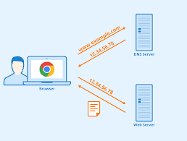

Main DNS server types:

## Resolver:

A resolver is the first stop in a DNS query, this acts as the middle link between the client and a DNS name server, once a DNS query has been sent from the client a recursive resolver will bring back cached data if it is found in the cache, or it will send a request to a root name server, then another request to a TLD (Top Level Domain) name server and then a last request to an authoritative name server. If the recursive resolver does not have the website that is requested in its cache, then it will go through the process of getting the IP address of the website wanted and return it. It will then store this IP address in its memory for a period time. The period of time that it is stored in the memory is chosen by the owner of the domain by using a setting called time to live, in which how long the website stays in the cache’s memory for.

## Iterative

The iterative DNS query will query a DNS server for information on a website, the user will enter a website they are trying to find and then the resolver may provide an answer from the cached memory or will ask another DNS server if they have the answer by returning the address of that DNS server, if it cannot return a definitive answer it will ask the next server. The query will start at the root server and then go down the levels according to its referrals that it receives

## Root servers

The root name server for the DNS records is a server that has a big role in the translating of a domain name into an IP address for a computer, they answer requests made in the root zone of the DNS. The servers can answer queries records which are cached in the root zone. They can also divert other requests made onto the TLD server.

## TLD (Top Level Domain) name server

The TLD name server is referring to the last part of a domain name, the part after the dot. TLDs made up into two categories, a country TLD and industries TLD. For example .FR for France and .GOV for governments websites. The TLD is the highest level of domain names in the root zone of the DNS for the internet. For the other domains in lower levels, it is the last section of the domain name. The managing of the TLD name servers is take care of by the IANA (Internet Assigned Numbers Authority) which is a part of the organization ICANN.

## Authoritative name servers

An authoritative name server provides answers to an original DNS query. It does not provide answers of websites from the cached memory. The Authoritative name server provides answers to the recursive DNS name servers with IP mapping of the website (or other server) searched for. The authoritative name server holds the records for domain names, these can be either A, CNAME, MX, NS, SOA or TXT records. An example could be if a DNS server in a network has stored a record for a website for example www.abc.com, then it would be that this DNS server is the authoritative server for the abc.com domain.

## URLs

A URL is the address of the website that you type into the address bar in a browser. A URL is unique and cannot be shared between different websites, it is just like a fingerprint with a person each person’s fingerprint is unique to them and there is no other the same. A URL is organized by the structure of different parts, this example shows the different parts of a URL and how they are organized – https://moodle.nptcgroup.ac.uk. The HTTPS is the protocol that is used to send data over the browser and the website you want to connect to. The host is “Moodle” which is the name of the web servers where it can be accessed. Then the .ac is the second level domain, this is showing that it is an academic second level domain and is used by universities and colleges in the UK. Then the .uk is the top level domain, this is the highest level of domain and shows that it is in the country of the UK by its top level domain. This is the end of the URL and is normally either a company (.com), country (.fr) or a government (.gov)

Domain name management includes keeping the DNS up to date, the management aspect of it is controlled using a portal by a third-party company. Utilizing this portal, the individual or business site can control DNS records which allow access the site, your blog, mail and other online resources. Lots of companies online offer services that will control your domain names for you, these will keep your domain name from expiring by offering an auto renewal service in with their benefit. Once your domain name is up and running you'll then utilize the portal to oversee your domain and all perspectives of it effectively from one place, you can there alter the DNS records rapidly and effectively for different domains

# Domain Name

A domain name is an internet resource name that's generally understood by Web servers and online organizations and gives all relevant destination information. To get to an organization’s Web-based services, site clients must know the exact domain name. Domain names are used worldwide, particularly in the world of networks and data communication. The following points explain how they work and how they are used:

* Domain names have two parts that are separated by a dot, such as example.com.
* A domain name can be used to identify a single IP address or group of IP addresses.
* A host or organization may use a domain name as an alternate IP address because domain names are alphanumeric (as opposed to all numbers), making them easier to memorize.
* A domain name is used as part of a URL to identify a website.
* The part that follows the dot is the top level domain (TLD), or group to which the domain name belongs.
* The IP address in the domain name’s background is converted to a recognizable, alphanumeric domain name by a system known as the domain name system (DNS).

## Domain Name management

Domain management, also known as domain name management, is the process of keeping a personal or business domain (or domains) stable, safe, and capable of supporting connected websites. The domain name not only establishes the owner's online presence, but it also serves as a gateway to a business or personal website customized to the owner's specific needs. Site owners may be tempted to spend all of their time to building and maintaining the website itself, but domain management is an important part of keeping the website up and running. There are simply a few steps to securing a domain. Finding the right domain name can take some time and thought, as well as the use of online tools to conduct a domain name search and check availability, but once a name has been chosen, all that's left to do is register it with an independent registrar or a web hosting company for a one- or multi-year term. The name is assigned to a host's primary and secondary domain, which point the domain to a website, once it is registered.

Individuals and small businesses may discover that all they need is a single domain name to establish a web profile and build a brand. Larger businesses and those with a variety of business interests may require numerous domains. Many registrars advise purchasing as many comparable domain names as possible to prevent them from being utilized by rivals and to catch all possible variations that may be entered in during a search, including misspellings. As a result, you may end up with a vast portfolio of domain names, some of which will likely never be utilized. Whether a user purchases one domain or several, continual management ensures that they are kept up to date and functional to support the websites they support.

## How does domain management work?

Domain management can take several shapes, depending on the goals and needs of the domain owner. However, a domain owner must be able to conduct key operations such as renewing or cancelling domain name registration, identifying domains and hosting providers, and making necessary modifications to domain names.Because a domain develops its owner's online identity, it's important to focus out for similar names that might affect a brand's reputation or authority, as well as analyzing statistics to see how it performs in searches. Security—validating IP addresses linked with the domain and monitoring for suspicious access to the domain—is another important aspect of domain management.

## Domain management tools and options

The registrar can give essential domain administration tools, or they can be integrated into the control panel supplied by a web hosting service. These tools provide a graphical, non-technical interface for managing settings connected to a user's account's domains. Users may use these DIY management tools to conduct things like renew or cancel domain registrations, validate IP addresses, and configure domains.

Domain registration and renewal, maintaining multi-domain portfolios, and tracking domain performance are all activities that may be handled with a range of premium and free domain management tools available online. Domain name generators and other tools for managing various registrars and domains, as well as keeping domains safe, may be included in some.

## Domain management services

Businesses of all sizes frequently purchase numerous related domain names with different extensions, resulting in a big portfolio of domains, some of which may be unused for long periods of time or never be used at all. Others might be linked to separate domain or hosting accounts with various renewal periods. Domain management services, which offer a number of service options for managing and maintaining all active and inactive domains in a portfolio, can help business customers manage a large and diversified collection of domains.

To handle domain registrations and renewals, evaluate the portfolio and delete unused and unwanted domains, and maintain domain security, domain management services use their own set of domain management tools. These services may work with customers to fix issues and make adjustments to current domains or the portfolio as a whole, thanks to advanced analytics for detecting unauthorized uses, site performance, and other key indicators. While domain management services are most commonly used by bigger companies, they may also be a good option for busy domain owners running small or medium-sized businesses, or even individuals who don't wish to handle their own domains.

# P2: Explain the purpose and relationships between communication protocols, server hardware, operating systems and web server software with regards to designing, publishing and accessing a website.

# Communication Protocols

In the world of technology, there are endless numbers of users' communicating with different devices completely different languages. That also includes numerous ways in which they transmit information alongside the diverse software they implement. So, communicating around the world will not be possible if there were no fixed 'standards' that will oversee the way user communicates for information as well as the way our devices treat those data. Here we are going be talking about these standard set of rules:

Transmission Control Protocol (TCP): TCP is a popular communication protocol which is used for communicating over a network. It divides any message into series of packets that are sent from source to destination and there it gets reassembled at the destination.

Internet Protocol (IP): IP is designed explicitly as addressing protocol. It is mostly used with TCP. The IP addresses in packets help in routing them through different nodes in a network until it reaches the destination system. TCP/IP is the most popular protocol connecting the networks.

User Datagram Protocol (UDP): UDP is a substitute communication protocol to Transmission Control Protocol implemented primarily for creating loss-tolerating and low-latency linking between different applications.

Post office Protocol (POP): POP3 is designed for receiving incoming E-mails.

Simple mail transport Protocol (SMTP): SMTP is designed to send and distribute outgoing E-Mail.

File Transfer Protocol (FTP): FTP allows users to transfer files from one machine to another. Types of files may include program files, multimedia files, text files, and documents, etc.

Hyper Text Transfer Protocol (HTTP): HTTP is designed for transferring a hypertext among two or more systems. HTML tags are used for creating links. These links may be in any form like text or images. HTTP is designed on Client-server principles which allow a client system for establishing a connection with the server machine for making a request. The server acknowledges the request initiated by the client and responds accordingly.

Hyper Text Transfer Protocol Secure (HTTPS): HTTPS is abbreviated as Hyper Text Transfer Protocol Secure is a standard protocol to secure the communication among two computers one using the browser and other fetching data from web server. HTTP is used for transferring data between the client browser (request) and the web server (response) in the hypertext format, same in case of HTTPS except that the transferring of data is done in an encrypted format. So it can be said that https thwart hackers from interpretation or modification of data throughout the transfer of packets.

Telnet: Telnet is a set of rules designed for connecting one system with another. The connecting process here is termed as remote login. The system which requests for connection is the local computer, and the system which accepts the connection is the remote computer.

Gopher: Gopher is a collection of rules implemented for searching, retrieving as well as displaying documents from isolated sites. Gopher also works on the client/server principle.

Some other popular protocols act as co-functioning protocols associated with these primary protocols for core functioning. These are:

* ARP (Address Resolution Protocol)
* DHCP (Dynamic Host Configuration Protocol)
* IMAP4 (Internet Message Access Protocol)
* SIP (Session Initiation Protocol)
* RTP (Real-Time Transport Protocol)
* RLP (Resource Location Protocol)
* RAP (Route Access Protocol)
* L2TP (Layer Two Tunneling Protocol)
* PPTP (Point To Point Tunneling Protocol)
* SNMP (Simple Network Management Protocol)
* TFTP (Trivial File Transfer Protocol)

# Server

A server is a computer, a device or a program that is dedicated to overseeing network resources. They are called that because they “serve” another computer, device, or program called “client” to which they provide functionality. There are a number of categories of servers, including print servers, file servers, network servers and database servers. In theory, whenever computers share resources with client machines they are considered servers. However, servers are often referred to as committed since they carry out hardly any other tasks separated from their server tasks.

The purpose of a server is to manage network resources such as hosting websites, transmitting data, sending or receiving emails, controlling accesses, etc. The server is connected to a switch or router used by all the other network computers can use to access the server’s features and services (browsing websites, checking emails, communicating with other users, etc.). Some of the most common types of server include:

Database servers:They allow other computers to access a database and retrieve or upload data from and into it.

File servers:They provide users with access to files and data stored centrally.

Web servers:They deliver requested web pages to multiple client web browsers.

Mail servers: They are a sort of “virtual post office” that store and sort emails before they are sent to users upon request.

Application servers: They are servers that provide an environment with all the necessary requirements to run or develop an application.

Other types of server include:

* Proxy servers
* Cloud servers
* Policy servers
* Blade servers
* Print servers
* Domain name services

Nearly all personal computers are capable of serving as network servers. However, usually software/hardware system dedicated computers have features and configurations optimized just for this task. For example, dedicated servers may have high-performance RAM, a faster processor and several high-capacity hard drives. In addition, dedicated servers may be connected to redundant power supplies, several networks and other servers. Such connection features and configurations are necessary as many client machines and client programs may depend on them to function efficiently, correctly and reliably. For example, servers must be able to stay always on to deliver their services, and they’re set up with a certain degree of fault tolerance to reduce the risk of causing service issues. In order to operate in the unique network environment where many computers and hardware/software systems are dependent on just one or several server computers, a server often has special characteristics and capabilities, including:

* The ability to update hardware and software without a restart or reboot.
* Advanced backup capability for frequent backup of critical data.
* Advanced networking performance.
* Automatic (invisible to the user) data transfer between devices.
* High security for resources, data and memory protection.

Server computers often have special operating systems not usually found on personal computers. Some operating systems are available in both server and desktop versions and use similar interfaces. However, an increase in the reliability of both server hardware and operating systems has blurred the distinctions between desktop and server operating systems.

# Operating System

An Operating System (OS) is a software that acts as an interface between computer hardware components and the user. Each computer system must have at least one working system to run other programs. Applications like Browsers, MS Office, Notepad Games, etc., require a few environment to run and perform its tasks. The OS helps you to communicate with the computer without knowing how to talk the computer’s language. It isn't possible for the user to use any computer or portable device without having an operating system.

## Types of Operating System (OS)

Following are the popular types of OS (Operating System):

* Batch Operating System

A few computer processes are exceptionally long and time-consuming. To speed the same process, a job with a similar type of needs are bunched together and run as a group. The user of a batch operating system never directly interacts with the computer. In this sort of OS, each user prepares his or her work on an offline device like a punch card and submit it to the computer operator.

* Multitasking/Time Sharing OS

Time-sharing operating system empowers individuals located at a different terminal(shell) to utilize a single computer system at the same time. The processor time (CPU) which is shared among different users is named as time sharing.

* Real Time OS

A real time operating system time interval to process and respond to inputs is very small. Examples: Military Software Systems, Space Software Systems are the Real time OS example.

* Distributed OS

Distributed systems use many processors located in different machines to provide very fast computation to its users.

* Network OS

Network Operating System runs on a server. It provides the capability to serve to manage data, user, groups, security, application, and other networking functions.

* Mobile OS

Mobile operating systems are those OS which is especially that are designed to power smartphones, tablets, and wearable devices.

# Web server

Apache is the most commonly used web server software on the market. Apache is an open source software and is maintained by a community of developers whilst being backed by the Apache Software Foundation. Apache is a good software to use on a web server as it is free to use and download and is most often used on Linux servers. Microsoft have their own web server software called IIS (Internet Information Services) it is not free like Apache and requires a license and will only runs on its windows operating systems. The Microsoft software comes with a tidy but takes some time getting used to GUI, it comes with a panel to manage the connected servers, but everything is one place to is very easy to manage.

It also comes with good security features such as the TLS certificate management and binding for enabling HTTPS and SFTP on to your websites. It also has software patches which are regularly rolled out to keep up with the latest security threats in the world. The security features in Microsoft’s software help to keep websites on the servers up and running and keep down time to a very low level, this will help company’s keep their financial losses down if their website does get attacked.

Most companies will use severs to host their websites on, it is not essential but is recommended as servers are needed to run all day every day of the year. A server needs to be reliable more reliable than workstations in a business as they are always on. The main job of a web server is to deliver the content of a hosted websites on the internet to the client. All computers that host websites must have web server programs, the most widely used web server program is Apache. Any computer as long as it is connected to the internet can be used as a web server as long as it has the appropriate software installed. Web servers typically host many websites, some only host a few. Servers that host multiple websites are called shared host while servers that host a website for a single company or person is call a dedicated host, these dedicated host are appropriate for websites with a high volume of traffic and sites that require custom server modifications.

# P3: The capabilities and relationships between front-end and back-end website technologies and how these relate to presentation and application layers.

In web applications, the term front end refers to the code executed within the browser, and back end to code being executed on the web server. Front end is frequently being called client side and back end as server side. Browsers can execute code within the form of JavaScript, using HTML for presentation and CSS for styling. Back-end is much more flexible, it can be modified in a lot of different languages, and the most popular is PHP, Ruby, ASP.NET and JavaScript (Node). The back-end development will store the data needed to have an online site on servers, the application and a database. To be able to form the server, application and database all to be able to work and talk together, a server-side language is used.

The database in web site is exceptionally critical because it stores information and is required within the improvement of websites. A commonly used database is MySQL it is used by numerous of the enormous companies and brands within the world such as Google, Facebook and PayPal. MySQL works by making a database for storing and controlling information, at that point clients can make ask by writing in particular SQL statements on MySQL and after that the server’s application will respond with the requested data and show up on the client’s side browser.

The back-end development of web site will have the language, database, security and backup side of it secured. The database of web site will be used in a query when somebody is for example looking for hotel inside a certain town, the database is capable for tolerating the query made by someone then it'll discover the information asked within the database and after that return it to the client that has looked for it on website .

The security side of the back-end development is critical in keeping information and sensate data safe. It is important that clients are logging in using the HTTPS protocol while doing any development as this will encrypt the data and cannot be catching by hackers. It is also important that the HTTPS is used on any websites that use credit card data as this will ensure that the data isn't capturing by hackers and will allow the user confidence to use websites that use this protocol, for example if they are shopping 84% of clients 7 would abandon their purchase if they cannot see that the HTTPS protocol isn't being used by the site. Google will rank sites higher in their search results if a location uses the HTTPS protocol, so it is better to use it in terms of getting your site higher up in the search results.

The front end of website is what happens in front of you, for example a browser will show you what you have searched within the browser. Part of the front-end development is the language html, this used along with CSS and JavaScript will help to construct the front end of an online site. The websites pages are created using these coding standards, they are styled to the way that a client would want by the developer. A web developer is the person or group that make the pages of website that we see on the screen, they are able to make websites without using any back-end coding or databases and these are called static websites. These static websites are used to show data for an online site. that does no require steady upgrading. For example, a restaurant seem have a inactive site to just show the menus and location maybe. They don't require information to be put away in a database, as the site may not require upgrading for a long period of time.

The presentation layer in the OSI model is responsible for translating data, encryption between applications and data compression. When data is passed through the HTTPS protocol on a browser, the data is encrypted as to keep it secure from people trying to hack and intercept it when it is transmitted over the internet. When this occurs the two devices that are talking to each other, for example when someone buys something off the internet, the HTTPS protocol is used to keep credit card information safe. When this happens the buyer and the seller will exchange keys to encrypt the data that is being transmitted, and this means that only these two can encode the data and then decode it in to a readable format, to keep it secure even if it does get intercepted by a hacker, they cannot retrieve any information from the hacked data as they do not have a key to decode it. The presentation layer is also used when building a website, HTML, CSS and JavaScript are used to connect the user interface with the back end of the website.

In the application layer the FTP protocol is used in this layer to transfer files between the server and the client over a network, this is used when upload files to a web server to host a website for example. The application layer is what provides the interface of the applications and network, it is the only layer that deals with the user that is using the computer. This is also where the DNS protocol is used as well, there are many other protocols that are used in the application layer and they include the SMTP, Telnet and TFTP. Applications that are run on a computer are using this layer as this hosts the applications that run on computers, when accessing the internet they are used there. The mail protocol is on the application layer and uses the SMTP protocol to send emails on the internet, then to receive emails the protocol used is the POP3 protocol. The Telnet protocol is also on the application layer, and this protocol is used to access a device remotely.

# P4:Discuss the differences between online website creation tools and custom-built sites with regards to design flexibility Performance, functionality, User Experience (UX) and User Interface (UI).

**Online website creation tools and custom-built websites**

Creating a template for a website is a great way to start building one instead of just building from scratch. There are many websites that come with various template options that will help in giving you a starting point. However, this method comes with some drawbacks, such as the possibility of getting carried away by the number of companies that are doing this type of work. Doing this method without any prior experience is a risky one. But then on the other hand it is a much quicker and easier way than building from scratch as everything is there on the creation tools for you to use.

The user experience of a website made with an online service may not be as excellent as a custom-crafted site since you will be limited in how you may lay out your website using their tools. You may want to change the flow of your website using the tools, but you may be limited in what you can do by the service itself. For example, if you wanted a user to navigate from one page to another in your own way, but you are unable to do so using the online creation tools, this will have a negative impact on the user's experience with the website. When a site is custom built to order, however, the user may customize it the way they want it to function, and the user experience is exactly what they expected and what works best.

Using a custom designed website is more efficient in terms of website performance since it will only contain the code necessary to operate the website and nothing more, unlike online creation tools, which will have a lot of extra code to assist the user create their website while making it very easy to use. This method will result in the addition of more code than is necessary, as well as a decrease in website performance. The flexibility of a custom designed website is far better to that of online services, since you may add and move whatever you want. Online creation services, on the other hand, limit users' website flexibility, which can be quite frustrating.

A custom-built website will always be accessible and functional on all platforms, including desktops, phones, and tablets. This is especially crucial these days, as many people use their tablets and phones to access websites on the move. A custom-built website will guarantee that the site is optimized for usage on both of these devices, and that the user interface is exactly as it should be when the website was created. When using an online creation service, viewing in mobile mode may not always be included in the standard service and may need additional fees. They will also typically appear higher in Google search results since the site has been optimized to appear higher in the search, which includes using key terms and properly constructing the page.

Using an online service will help a user in that once their website is up and running, they will not have to worry about security because the service you have selected will take care of it. Furthermore, the organization handles data storage and upkeep, allowing the customer to focus on other tasks. When utilizing a custom-built website, this is a problem to consider because there will be higher expenses for data storage due to the necessity for hard drives to store the data on. Support is also an important aspect of a website; with a custom-built site, you will always have access to continuing support from the business you used. However, the help provided by an online service will be weaker than that provided by custom-built providers, who are able to give more personalized care than an online service.

# Conclusion

As a result, I've written a paper that describes the purpose of DNS, as well as the many forms of DNS and how domain names are organized and handled. In terms of web creation, publishing, and accessing a website, I also covered the purpose and relationships between communication protocols, server hardware, operating systems, and web server software.

# Part2:

# Introduction

This is the second part of my project, in which I will build a whole website using the full software development lifecycle, which will include everything from data collecting through website testing. The Nepal Tourism Board, a non-profit government body whose aim is to promote tourism in Nepal, has launched a new website. This website aims to provide national and international visitors with travel and tourism-related services. For individuals and groups organizing trips to various regions of Nepal, the Nepal Tourism Board is searching for a website that combines components such as online hotel booking, transportation booking, and other entertainment options.

According to the Nepal Tourism Board's requirements, I created a high-fidelity design that includes client and user demands. This website supports CRUD functionality and has over 10 pages. I've created plans based on the specifications, and I'll put them to the test before making them public.

# User Requirements

Users and indeed all stakeholders, especially those who gave you money to develop the product, must be able to comprehend user needs so that they may play smart by telling you what to do if they want to. To achieve such mutual understandings, user needs must be defined in the business domain and in any format requested by stakeholders. Some people cannot read text and prefer to communicate everything through diagrams, while others prefer to express everything through texts and tables, while still others can only understand through metaphors and/or instances. You'll be surprised by people's communication techniques. The user needs should be expressed in the simplest possible technical terms. People are afraid of things they don't comprehend by nature.

# System Requirements

The development team must understand how to achieve user needs practically using current technologies, therefore system requirements are for them. They typically overlap and, in some circumstances, completely replace high-level designs. They're more crucial for punishing the clever team members so that everyone is on the same page, and for keeping those arrogant heads clear so that they can see where they're going. Non-technical users or stakeholders would struggle to comprehend these needs, which is often the basis of many ills and trust concerns. Unfortunately, the world is filled with individuals that are quite different from one another, and no one is powerful enough to do everything on their own. As a result, we require teamwork. And, first and foremost, excellent communication and mutual understanding are required. As a result, we require both User Requirement and System Requirements.

# P5:Create a design document for a branded, multipage website with medium fidelity wireframes and full set of client and user requirements.

## Proposal document:

For the Nepal Tourism Board, I designed a multi-page website that would act as a guide for people visiting Nepal. This website will include photographs of several areas in Nepal, allowing travelers to choose where they want to visit. This website will include provide CRUD functionality, as well as the ability to book hotels and transportation to those areas.

## Objectives

The following are the primary goals of the project's development:

• To promote tourist destinations

• To make travel easier by providing travel and lodging information

## Scope

This project would assist people in exploring different tourist destinations in Nepal. This project has the potential to bring in foreign visitors while also helping the local economy. This also adds to the country's economic development. People will also be able to quickly access information prior to their trip, and they will be informed of the places they want to see ahead of time.

## Timeframe

Every project will be given a deadline for completion, and this project does too. This project is expected to be completed in three months. As a result, I've set down the following amount of time:

|  |  |  |
| --- | --- | --- |
|  | Description of work | Start and End date |
| Phase 1: | Discovery Phase | 1st march – 15th march |
| Phase 2: | Design Phase | 16th march – 31th march |
| Phase 3: | Development Period | 1st April– 30th April |
| Phase 4: | Modification and Testing Period | 1st may –20th may |
| Phase 5: | Launch and Maintenance | Approx. 2 weeks. |

The first phase is discovery.

This is the step in which we gather the data required to create any program. This phase comprises speaking with clients about their needs and the features that will be incorporated in the software or program under development. We will advise clients on the features to include in the system, as well as security measures and the software's total cost. We will communicate with the customer and listen to their demands in the application. If we feel we can provide them better solutions, we will give ideas. After that, we create a project plan and talk about it with the customer. We will describe how their apps will function and work during the session.

### Second phase is Design.

The designing step follows, in which we will construct a mockup of the website's wireframe based on our strategy. We'll also add brand logos, colors, and a sense of direction. Images, web assets, typefaces, and other items might be included.

We'll develop a responsive layout grid, typography, and base style guide with title and text styles that include buttons, blocks, and more, based on the client's anticipated documentation.

Based on our final website, we will design comprehensive prototypes and schematic design. It will serve as the foundation for the development of the website.

### The third phase is Development

In the development phase, we'll turn the design and concepts into reality. We begin coding our project based on our design and outline after finishing the concept and agreeing on the design with the customer. This is the longest and most important stage of web development. Within the time limit mentioned, I will complete the website and all of its components. I need to make sure the website is safe because it will be keeping user information. The database for this website will also be established and protected at this phase.

### The fourth Phase is Testing and modifying

We will test the site once it has been fully completed to ensure that all of the functionalities work properly. We'll also evaluate the website's security measures, as it's vital that it's safe. We'll be testing the website to make sure it works properly. The customer will be shown the completed website so that they may offer input. Based on the client's comments, we may then improve the website. The website will need to be modified until the customer is happy with the results.

### The fifth phase is Launch and Maintenance

After the testing and modification processes are done, we will launch the website so that anyone may utilize it. We'll keep an eye on the website's operation because it might crash or have other faults. We will have to re-maintain the website as well as remove the problems and mistakes if any of the possible events occur.

## Stakeholders

A stakeholder is a person or company who has an interest in the company and can either influence or be influenced by it (Investopedia, 2020). As a result, the website's stakeholders will include tourism-related locals, tourists, hotel owners, transportation owners, the government, and so on.

## Wire frame design

A wireframe is a black-and-white line drawing used in early-stage web design to demonstrate the layout and information architecture of a web page to stakeholders. Wireframes are problem-solving tools that help members of the design team prioritize content placement on a page and discover user experience (UX) concerns early on. The backbone of the website is provided by the framework, which was inspired by the usage of wire mannequins in the fashion industry. The header and footer, search field, breadcrumb trail, site navigation, body content, and share buttons are all represented in wireframes by boxes of various sizes. Unlike a page mock-up, which is a more full prototype that usually contains logos, color, photos, typeface options, and content, a wireframe's skeleton approach allows design team members to experiment with page component placement and make changes fast without needing too much time or effort.

A wireframe is a way of structurally creating an online service. A wireframe is a tool for laying out content and functionality on a page while considering user wants and journeys. Wireframes are used to define the fundamental framework of a page early in the development process, before visual design and content are incorporated. A wireframe is a diagram of a web page's layout that illustrates which interface components will appear on important pages. It's a crucial step in the interface design process. The goal of a wireframe is to offer a visual representation of a page early in the project so that stakeholders and project team members may approve it before the creative process begins.

## Design page

Web design refers to the process of creating websites. It consists of a number of components, including homepage layout, content production, and graphic design. Web design is a subset of web development, despite the fact that the terms web design and web development are commonly used interchangeably. HTML is a markup language for creating websites. Web designers utilize HTML tags to describe the content and metadata of each page. CSS, or cascading style sheets, is a technique for defining the layout and appearance of elements on a webpage. As a result, most websites describe how each page will appear in a browser using a mix of HTML and CSS.

## Principle of design

Web design includes not just the appearance and feel of a website, but also how it performs and reacts. When web designers work on a website, they try to make it as responsive, functional, fast, and helpful as possible, in addition to adding visual appeal. Designers employ particular principles to create a website that is both usable and functional. These suggestions or essential ideas to remember are what these principles are for. By incorporating design principles into the website's design, we can make it more responsive, functional, fast, and useful. There are various web design rules that must be followed in order to make a great website. Websites must adhere to particular standards, including an intuitive structure, visual hierarchy, accessibility, communication, and content, as well as frequent testing.

So, to develop a successful and effective website developers must follow these standard points:

* The design should have a very intuitive structure and be easy to understand so that consumers don’t have to ponder about which route to proceed.
* Each page of our website must have a distinct purpose and be designed to meet a specific requirement for our visitors in the most efficient manner feasible.
* The text must be readable, the colors should not be too bright, and the background should not overshadow the information, among other things.
* The user interface of the site design must be such that people can grasp everything in the most convenient way;
* The user interface of the site design must be such that people can grasp everything in the most convenient way; Readability, legibility, color, texture, and viewpoints must all be balanced.
* Websites must be suitable, well-written, and simple to comprehend, and they must be written with search engine optimization in mind.

## Factors of Website Development and Designing

In today's era of technological upheaval, if your company doesn't have a website, it doesn't have a personality. Detailed descriptions or writings are not required to convey the importance of the advanced world. Everyone understands that effective marketing is crucial to a company's success and income. Your company's website is the key way of computerized proximity. A website is a collection of pages that contain your webpage's content. A small number of companies manage their whole operation through their websites. This suggests that you should establish a website for your business. The website may be quite beneficial to your website and can also be used as a front end. In this post, we'll cover a component of any business's website composition:

### Usability

One of the most important aspects of web design is making the site useful for the average user. Because the majority of your website's users aren't professional HTML writers, things may need to be simplified a little.

### Speed

Your website's speed may harm the business. Despite the amazing technology involved in linking them to countless pages all over the world, users will go crazy if a page does not load within three to five seconds. They will most likely leave your website and never return, costing you potential business.

### Content

When it comes to what they desire, users are extremely selective. They will not be happy until your website contains intriguing and engaging content, even if it is easily accessible, functions well, and looks great. Marketing should be a part of any company's marketing strategy. People prefer video content over written content, as seen by the 50 billion monthly video views.

### Mobile friendly

Nearly half of all users say that if a company's website doesn't operate on their mobile device, the company doesn't care. Your company should be online in 2020, and your website should be mobile-friendly.

### Design environment

An engineering development environment is a collection of procedures and programming tools used by a company to aid in the development of a product. Aligning techniques and technology makes it easier for teams to collaborate and ensures that everyone's code contributions execute on everyone's system. Design may be addressed similarly. By putting in some time to set up a few important tools and procedures, we can be confident that our work will look and act consistently as we grow the team, collaborate on features, and build new products.

## Design

I began working on the website. I’ve included the source code as well as screenshot of the website of what it looks:

### Home page

It is the home page of the website, and it contains information about the Nepal Tourism Board as well as other features. It's the first page a user sees when they go to the company's website. It has a navigation bar with connections to different parts of the site. The home page of the Nepal Tourism Board website is shown below.

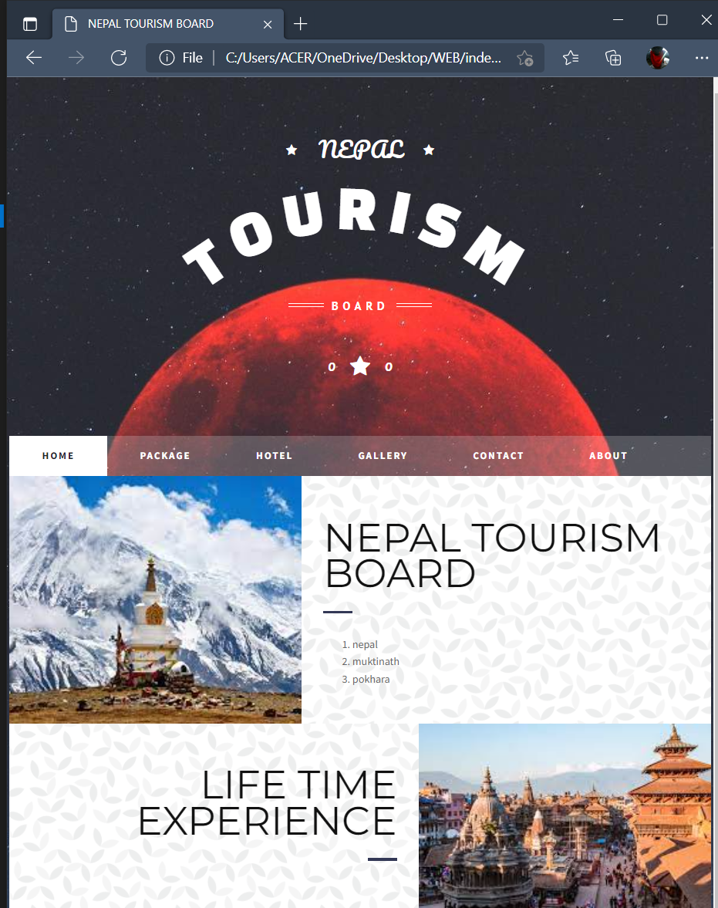

### Source code for home page

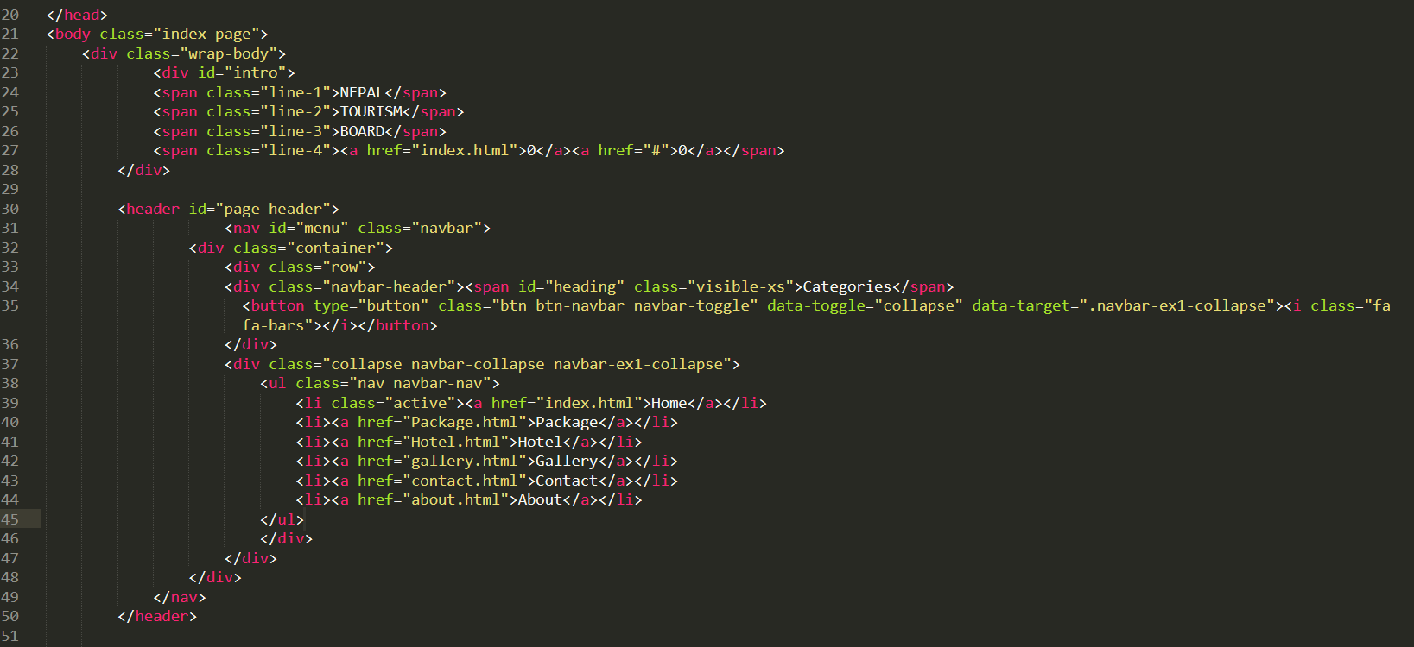

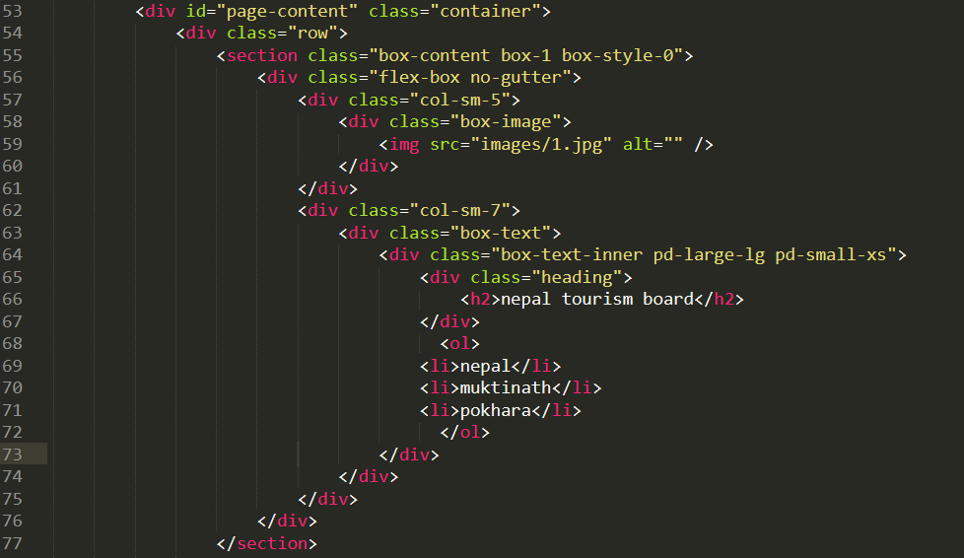

### Package page

We can choose from a variety of packages according on our preferences, which will include the quality of the hotel, transportation, and the number of days we will be spending there.

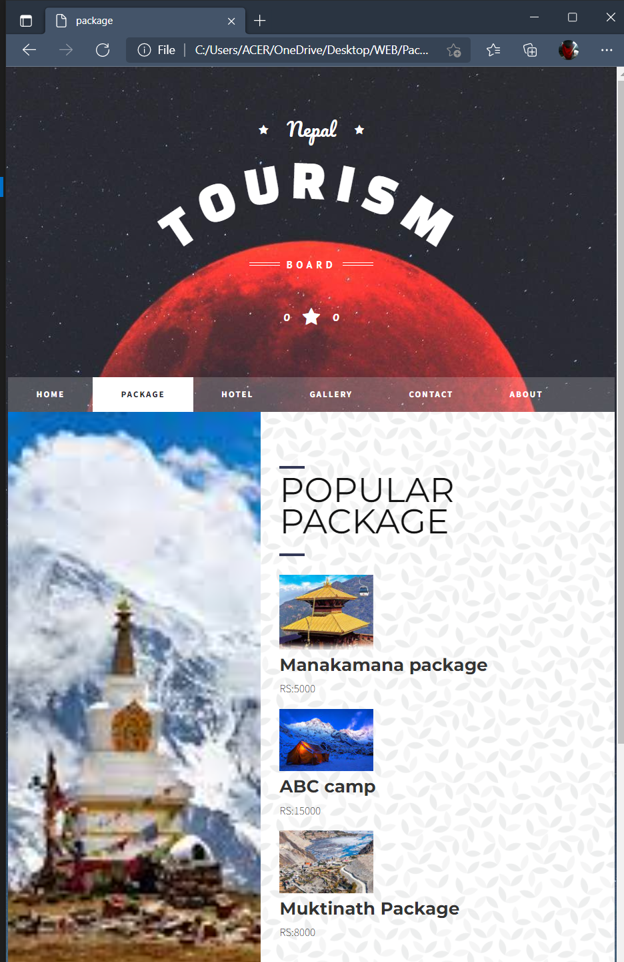

### Source code for package

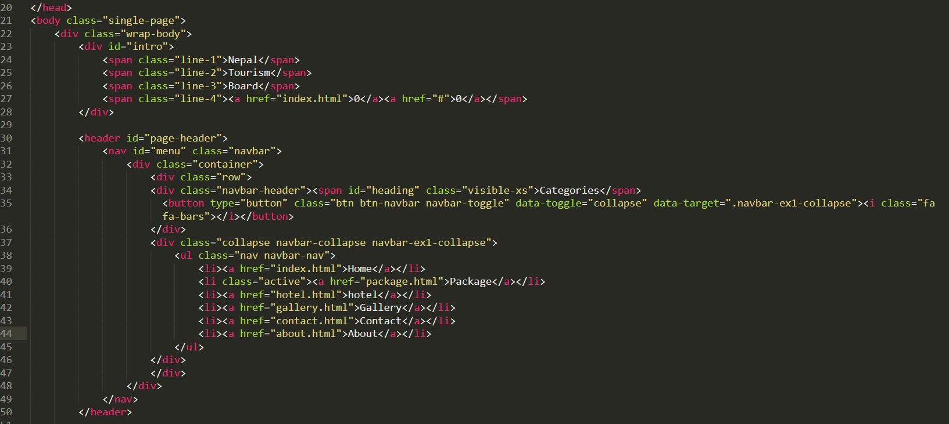

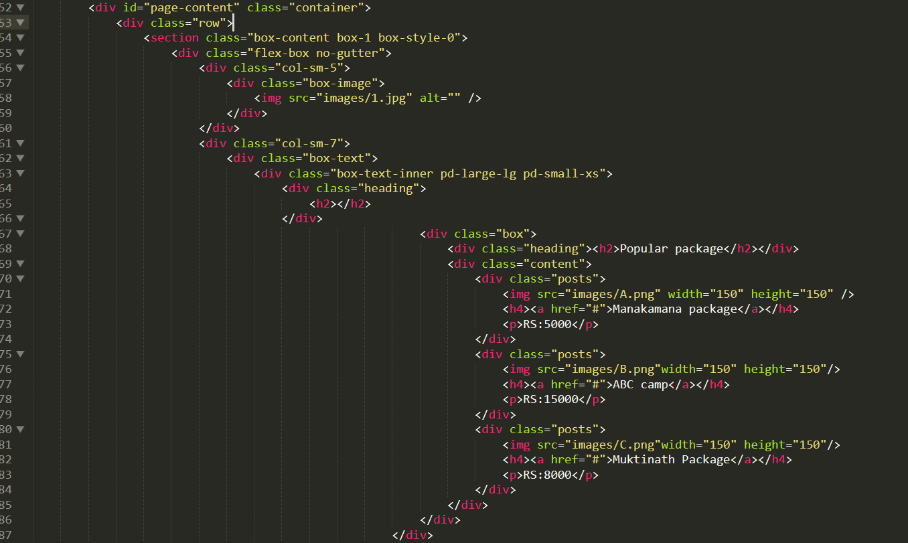

### Hotel Booking Page

This provides lists of hotels

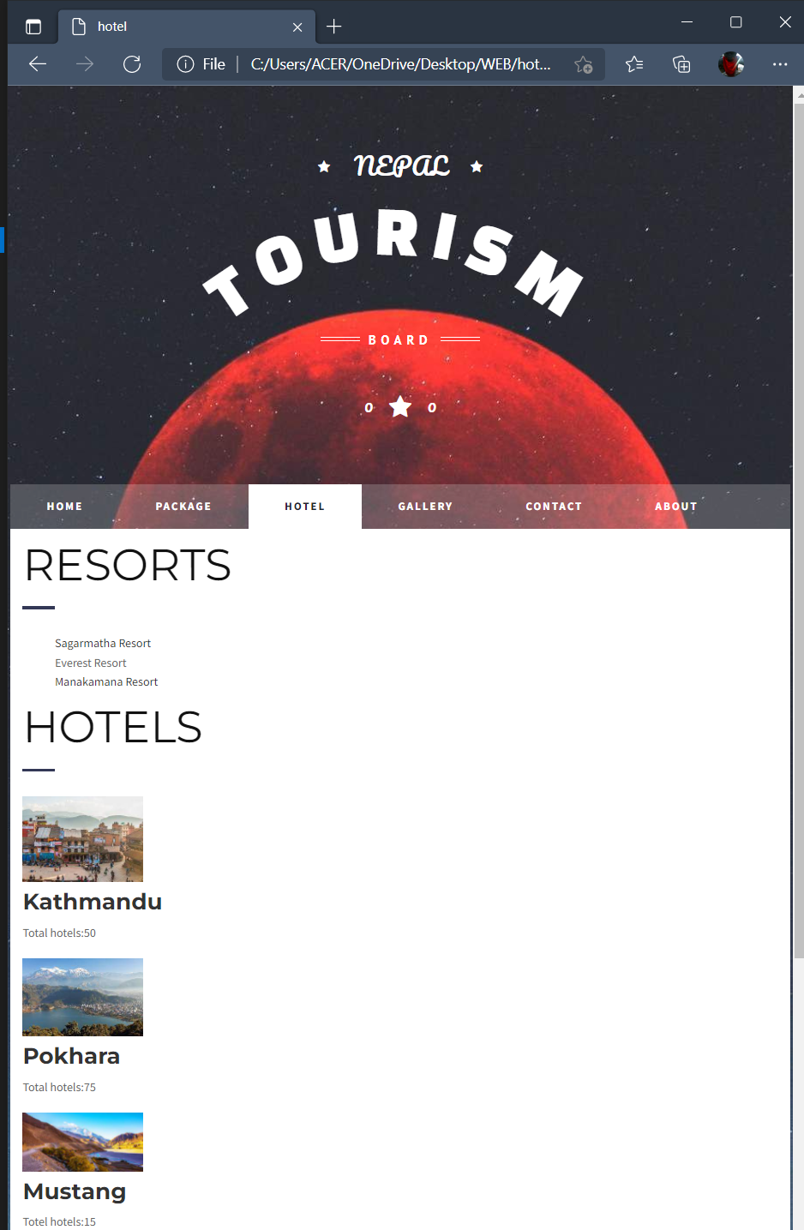

### Source code for hotel page

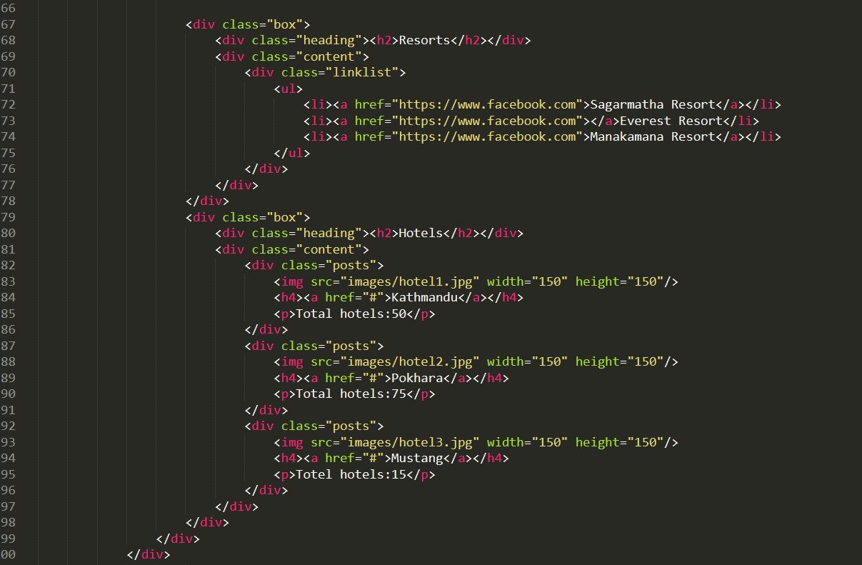

### Gallery page

This page covers photographs of Nepal’s various tourist destinations:

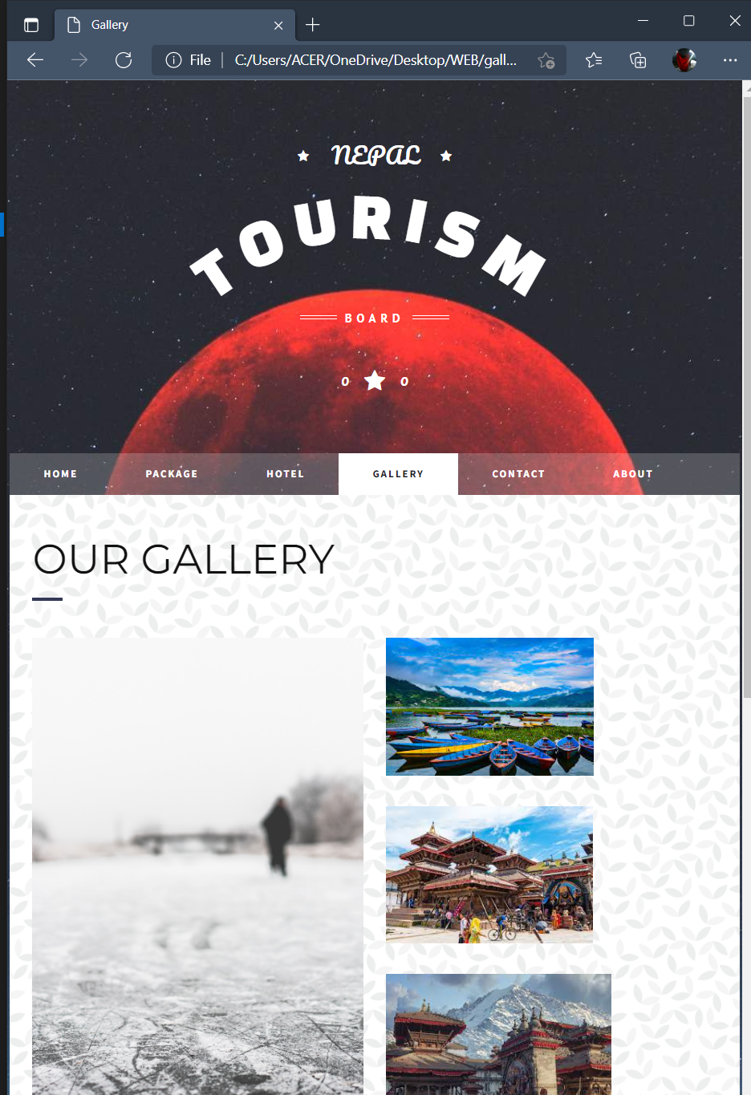

### Source code for gallery

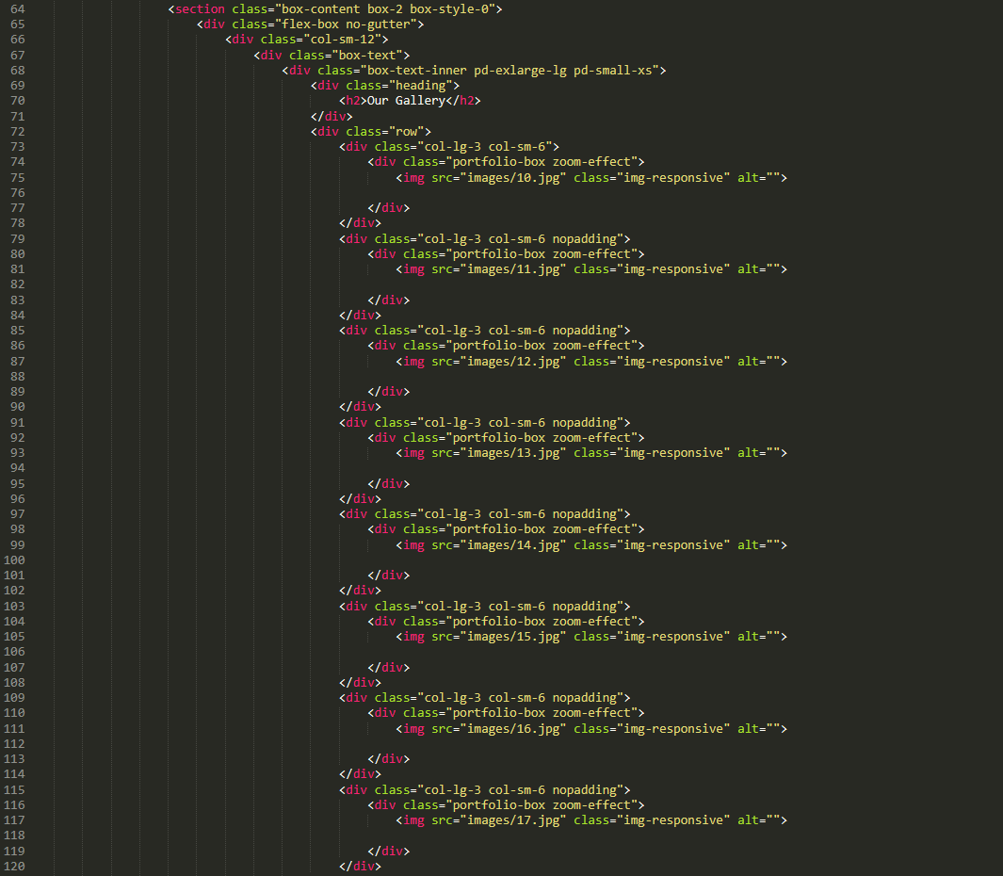

### Contact page

This page contains a form which contains message box where people can send their queries. The company have provided their contacts show that the customers can contact them if any need to know more about the company or to ask any queries related to the flight details, services, booing, etc. The contact page of the Nepal Tourism Board is shown in the screenshot below

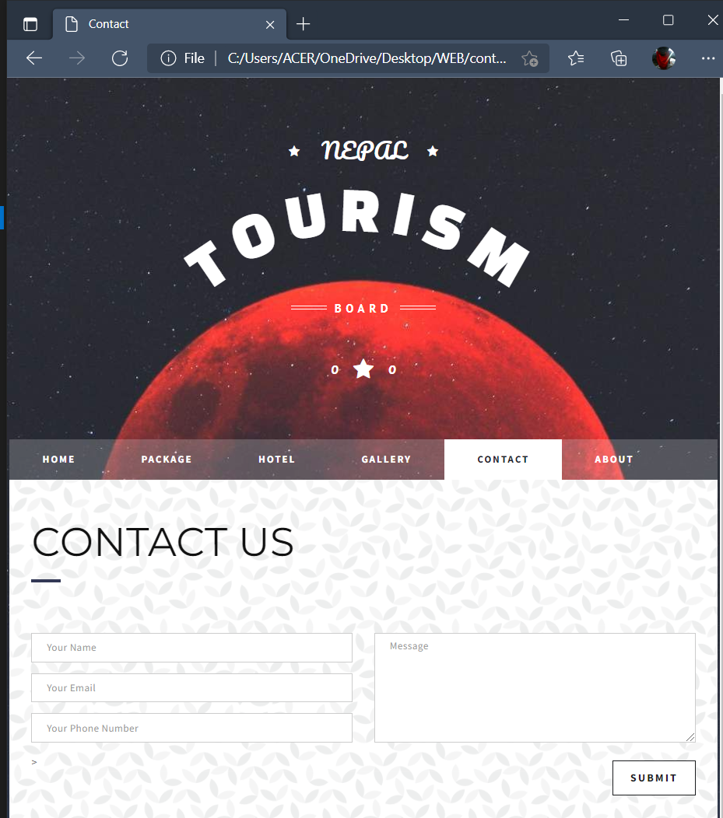

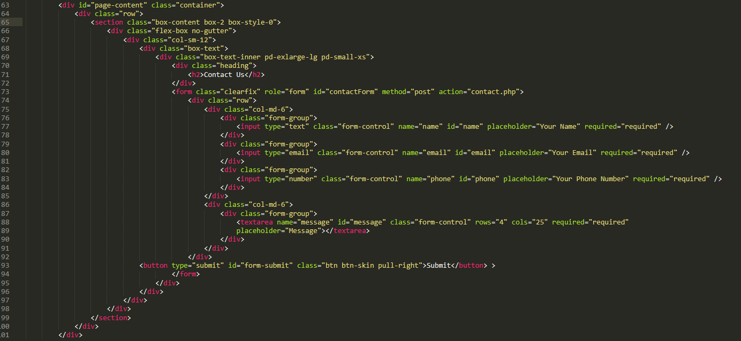

### About page

This page provides detail about Nepal tourism board.

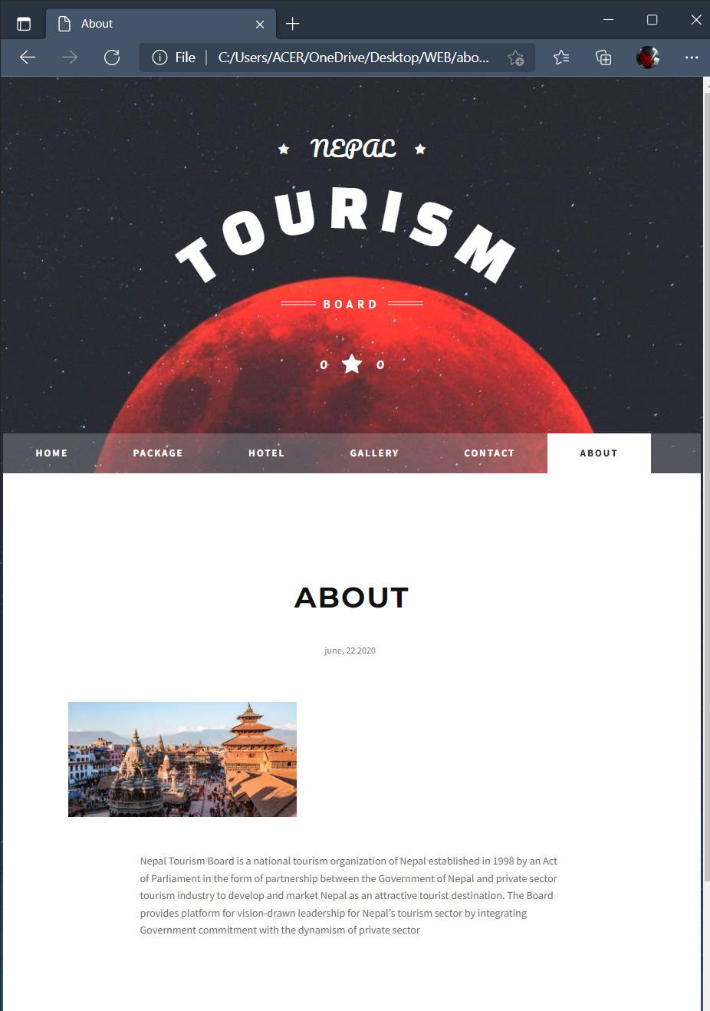

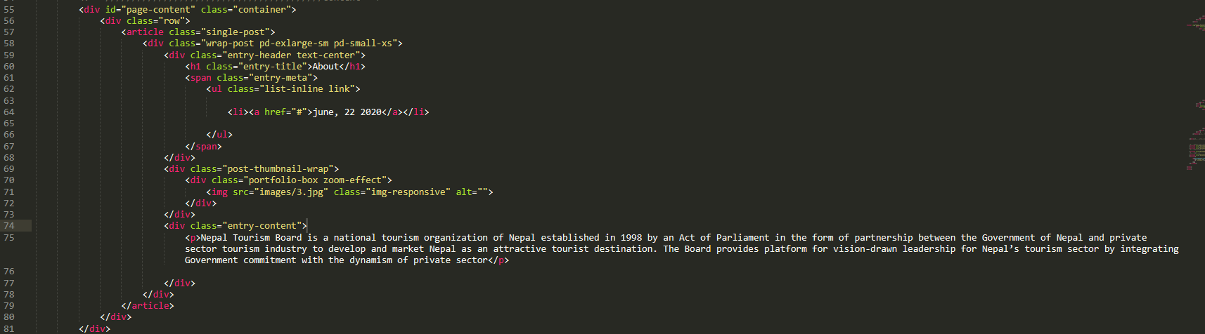

## Testing

Website testing is also known as website troubleshooting. It's vital to uncover any possible issues with a website before exposing it to the public. Testing may address and fix issues like as basic website functionality, user accessibility, and the site's capacity to adapt to responsive devices (such as smart phones, tablets, and desktop computers) prior to the launch of our website. Testing should look at how your site performs in a number of scenarios and settings. Stress testing exposes your website's server to high traffic loads in order to ensure that it can maintain its performance even if traffic spikes occur unexpectedly. The overall user experience is improved by testing the load times of your site's pages. Confirming your server's expanding capabilities helps to avoid common issues that small and large businesses face nowadays.

Summary reports from your testing provide your web development team a "big picture" perspective of your website and its performance concerns. There are several testing tools accessible, and you should choose one that provides the information you need while analyzing your website's design. A thorough testing approach assures the success of your website and gives your potential clients the greatest value.

## Types of testing :

### Accessibility Testing

Accessibility testing is the practice of ensuring your mobile and web apps are working and usable for users without and with disabilities such as vision impairment, hearing disabilities, and other physical or cognitive conditions.

### Acceptance Testing

Acceptance testing ensures that the end-user (customers) can achieve the goals set in the business requirements, which determines whether the software is acceptable for delivery or not. It is also known as user acceptance testing (UAT).

### Black Box Testing

Black box testing involves testing against a system where the code and paths are invisible.

### End to End Testing

End to end testing is a technique that tests the application’s workflow from beginning to end to make sure everything functions as expected.

### Functional Testing

Functional testing checks an application, website, or system to ensure it’s doing exactly what it’s supposed to be doing.

### Interactive Testing

Also known as manual testing, interactive testing enables testers to create and facilitate manual tests for those who do not use automation and collect results from external tests.

### Integration Testing

Integration testing ensures that an entire, integrated system meets a set of requirements. It is performed in an integrated hardware and software environment to ensure that the entire system functions properly.

### Load Testing

This type of non-functional software testing process determines how the software application behaves while being accessed by multiple users simultaneously.

### Non Functional Testing

Nonfunctional testing verifies the readiness of a system according to nonfunctional parameters (performance, accessibility, UX, etc.) Which are never addressed by functional testing.

### Performance Testing

Performance testing examines the speed, stability, reliability, scalability, and resource usage of a software application under a specified workload.

### Security Testing

Security testing unveils the vulnerabilities of the system to ensure that the software system and application are free from any threats or risks. These tests aim to find any potential flaws and weaknesses in the software system that could lead to a loss of data, revenue, or reputation per employees or outsides of a company.

### Single User Performance Testing

Single user performance testing checks that the application under test performs fine according to specified threshold without any system load. This benchmark can be then used to define a realistic threshold when the system is under load.

### Stress Testing

Stress testing is a software testing activity that tests beyond normal operational capacity to test the results.

### Unit Testing

Unit testing is the process of checking small pieces of code to ensure that the individual parts of a program work properly on their own, speeding up testing strategies and reducing wasted tests.

### White Box Testing

White box testing involves testing the product's underlying structure, architecture, and code to validate input-output flow and enhance design, usability, and security.

# Testing of my web site

|  |  |  |  |
| --- | --- | --- | --- |
| Test Date | Expected Output | Actual Output | Analysis |
| 2020-05-01 | The developed website must be compatible as it should open from the different browsers. | The website was accessible using a variety of browsers, including Google Chrome, Microsoft Edge, and Internet Explorer. | As the website was opened in multiple browsers such as Google Chrome and Internet Explorer, opera the expected and actual outputs were matched, indicating that our website is compatible. |
| Evidence | C:\Users\ACER\OneDrive\Pictures\Screenshots\Screenshot (92).png C:\Users\ACER\OneDrive\Pictures\Screenshots\Screenshot (100).png | | |
| 2020-05-07 | The website must access to the services when operated properly without any flaws. | When I clicked to the contacts page, it worked perfectly and without any glitches, as expected. | When I clicked to the contacts page, it worked perfectly and without any glitches, as expected. |
|  |  | | |
| 2020-05-15 |  | When I clicked to the gallery page, it worked perfectly and without any glitches, as expected. | When I clicked to the gallery page, it worked perfectly and without any glitches, as expected. |
|  | C:\Users\ACER\OneDrive\Pictures\Screenshots\Screenshot (95).png | | |

# Conclusion

The website was built keeping the goals and specifications of the Nepal Tourism Board in mind. I used my design document, as well as applicable concepts, standards, and rules, to construct a branded, multipage website with authentic content. And, as I have indicated, testing is critical. Different forms of testing have been considered, including black box testing, white box testing, stress testing, integration testing, and unit testing. My experiments were recorded on a log sheet with predicted and actual outcomes.

# References

<https://www.ukessays.com/essays/information-systems/purpose-and-types-of-dns-2.php#_Toc9437578>

<https://www.techopedia.com/definition/1327/domain-name>

<https://www.w3schools.in/types-of-network-protocols-and-their-uses/>

<https://www.techopedia.com/definition/2282/server>

<https://www.guru99.com/operating-system-tutorial.html#what-is-an-operating-system>

<https://www.cloudflare.com/learning/dns/dns-server-types/>

<https://www.home.neustar/blog/recursive-dns-what-it-is-and-why-you-should-care>

<https://domain.me/how-domain-names-work/>

<https://www.globalsign.com/en/blog/the-difference-between-http-and-https/>

<https://www.domain.com/blog/domain-management-101/>

<https://www.perfecto.io/resources/types-of-testing>